

*5010-50th Ave Leduc, AB T9E 6T3 Phone: (780) 980 2877*

*5109-50th Ave Wetaskiwin, AB T9A 0S5 Phone: (780) 312 2899*

Name: ________________________________________ Today’s date: ____________________

Address: ______________________________________ Phone: home ( )_____________________

City: _________________________________________ work ( )_____________________

Postal Code: ________________________________ cell ( )­_____________________

Email: ________________________________________ Date of birth: (YY/MM/DD) _________________

Would you like to receive our newsletter via e-mail? YES / NO (circle one)

Physician: ______________________________________ Phone:_____________________________

Emergency contact name: _________________________ Phone:_____________________________

Is this injury work related? YES / NO

Is the injury a result of a motor vehicle accident? YES / NO

How did you hear about fascial stretch therapy? ______________________________________________________

What are your goals for this therapy?­______________________________________________________________

**Your Health History**

Reason for your visit today (Chief Complaint): ________________________________________________________

What other treatments have you tried?

□ Massage □ Acupuncture □ Physiotherapy □ Chiropractor

□ Other - Please specify: _________________________________________________________________________

What have you tried that has helped?­­­­­­­­­­­­­­­­ ____________________________________________________________

What tests have you had for your symptoms and when were they performed?

_____________________________________________________________________________________

Have you had similar symptoms in the past? If so, what helped? __________________________________________________________________________________________________________________

Have you received FST or other types of bodywork before? YES / NO

Please describe: ________________________________________________________________________________

Have you had any surgeries, or have you been hospitalized within the last 5 years? _____________________________________________________________________________________

Allergies (Medication, Herbs, Food, or anything else): _____________________________________________________________________________________

Major injuries (broken bones, dislocations, sprain, strain, tears etc.): ___________________________________________________________________________

Prescription medications, vitamins, and supplements: _____________________________________________________________________________________

**Aches & Pains**

**Please indicate areas of complaints, pain or other symptoms on this diagram:**

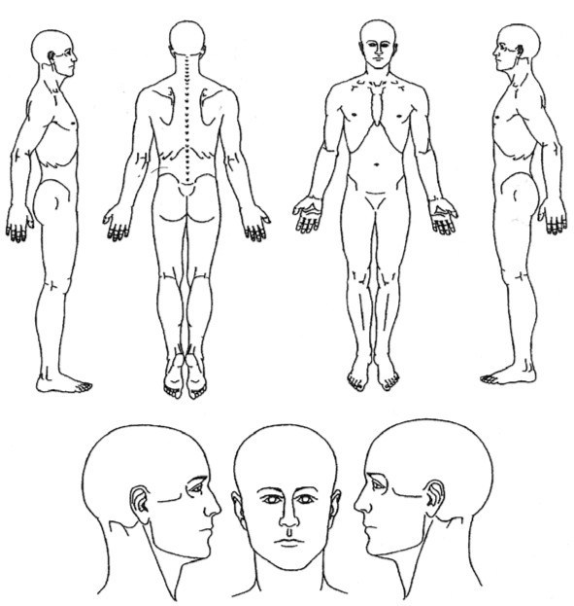

R

R

L

L

Please rate your currently level of pain: □ Severe □ High □ Moderate □ Low

Rate your current level of stress: □ Severe □ High □ Moderate □ Low

**Do you now have or ever had any of the following conditions? (please check)**

□ Headaches □ Back Pain □ Numbness □ Joint Dislocation(s) □ High/low Blood Pressure

□ Arthritis □ Diabetes □ Dizziness □ Asthma □ Multiple Sclerosis

□ Stroke □ Cancer □ Kidney disease □ Lymphatic condition □ Blood Clots

□ Cerebral Palsy □ Heart Disease □ Fibromyalgia □ Osteoporosis □ Chronic Fatigue Syndrome

**Lifestyle**

How much water do you drink each day? _________________________________________________________________

How many cups of coffee/tea do you drink each day? __________________________________________________

Do you smoke? If, yes, how many cigarettes do you smoke in one day? ____________________________________

How many hours of sleep do you get each night? _____________________________________________________

Do you wake up during the night? YES / NO If yes, how long are you awake? _____________________________

Do you have trouble falling asleep? YES / NO

Is there any other info you wish to provide to aid in the success of your care? _____________________________________________________________________________________

**Payment Agreement for Services**

Our office policy states that payment must be made in full, and I agree to pay in full for all services performed at Refresh Wellness Centre at the time of service, payable to the Practitioner providing my care, unless other arrangements have been made at the time of service.

If your account is not paid in full within 30 days, you will be responsible for any expenses incurred in the collection process of your account. If you are involved in any type of litigation case i.e.: auto accident and you choose to discontinue care before the doctor releases you, your balance will be due, immediately.

**Cancellation and Missed Appointment Policy**

Refresh Wellness Centre requires appointment cancellations be received in advance of 24hrs of a scheduled appointment. Any cancellations received within 24 hrs of a scheduled appointment time will result in a cancellation fee of **$50** charged to your account and payable at your next visit. **_____ (Patient initials)**

Any missed appointments (no shows) will be charged a missed fee at the **full fee** for the appointment missed. This fee is payable at your next visit. **______ (Patient initials)**

I, ___________________________________________________________, agree to abide by the above policies.

Patient/ Legal Guardian Signature: ________________________________ Date: ____________________________

**Reviewed with Patient (practitioner initial): __________**

**Personal Information Consent**

We are committed to protecting the privacy of our client’s personal information and to utilizing all personal information in a responsible and professional manner. This document summarizes some of the personal information that we collect, use, and disclose. In addition to the circumstances described in this form, we also collect, use, and disclose personal information where permitted or required by law.

We collect information from our clients such as names, home addresses, work addresses, personal and work phone numbers, and email addresses. (Collectively referred to as “Contact Information”). Contact information is collected and used for the following purposes:

* To open and update client files.
* To invoice clients for services or collect unpaid accounts.
* To process claims for payment or reimbursement from third-party health benefit providers and insurance companies.
* To send reminders concerning the need for further treatment and/or appointment reminders.
* To send clients informational material about our offices.

Contact information is disclosed to third party health benefit providers and insurance companies where the client has submitted a claim for reimbursement or payment for all or part of the cost of the service or has asked us to submit a claim on the client’s behalf.

We collect information from our clients about their health history and treatments, their family health history, and their physical condition. (Collectively referred to as “Medical Information”). Medical Information is collected and used for the purpose of providing treatment.

Medical Information is disclosed:

* To third party health benefit providers and insurance companies where the client has submitted a claim for reimbursement or payment of all or part of the cost of treatment or has asked us to submit a claim on the client’s behalf.
* To Refresh Wellness Centre practitioners at all locations for client treatment purposes.
* To healthcare professionals such as physicians if the client has been referred by us for treatment.

If we are ever considering selling all or part of our business, qualified potential purchasers may be granted access to client information to verify information important to the potential sale access as part of the due diligence process. If this occurs, we will take steps to ensure that the prospective purchaser safeguards all personal information.

To comply with the Canadian Anti-Spam Legislation in effect as of July 1, 2014, our office would like to have your express consent to continue communicating with you and providing you with important information from us. We are committed to never sending spam emails, and our privacy policy will always protect your electronic information. We do send information and/or communication via email and text for our patients’ convenience. If you decide to opt in and continue receiving emails and texts, you may withdraw your consent at any time.

____ YES, I give consent to receive communication and appointment confirmations via email and/or text.

____ No, I do not give consent. I prefer to receive telephone confirmations.

I consent to the collection, use and disclosure of my personal information as outlined above.

Patient/Legal Guardian: ________________________________ Date: _________________

Full Name (printed): _______________________________________________

**Informed Consent for Fascial Stretch Therapy**

I hereby consent for the certified Fascial Stretch Therapy Practitioners at Refresh Wellness Centre to treat me with Fascial Stretch therapy including assessments, stretches and other techniques that is within their scope of practice.

I acknowledge that the practitioner is not a physician and does not diagnose illness or disease or any other physical or mental disorder and that nothing said in the course of the session(s) given should be construed as such. I clearly understand that stretch therapy is not a substitute for a medical examination, and a referral from your primary care provider may be required prior to services being provided. I acknowledge that no assurance or guarantee has been provided to me as to the results of the treatment.

Because stretch therapy is contraindicated under certain medical conditions, I affirm that I have stated all my known medical conditions and answered all questions honestly. I agree to keep the practitioner updated as to any changes in my medical profile and understand that there shall be no liability on the practitioner’s part should I forget to do so.

It is understood that any illicit or sexually suggestive remarks or advances made by me, the client, will result in immediate termination of the session and I will be liable for payment of the scheduled appointment.

I understand that bodywork I receive is for the purpose of increased flexibility, stress reduction and relief from muscular tension, spasm, or pain, and to increase circulation. If I experience any pain or discomfort, I will immediately inform my practitioner so that the intensity and/or methods can be adjusted to my comfort level. I understand that utilization of this type of modality can possibly increase soreness and/or pain if I do not communicate honestly and or follow proper precautions following the course. I understand that information exchanged during any session is educational in nature and is intended to help the client become more familiar and conscious of his or her own health status.

Given the above, I understand that response to treatment varies on an individual basis and that specific results are not guaranteed. I understand that I am choosing Frederick Stretch Therapy at my own risk. In the event that I become injured either directly or indirectly as a result, in whole or in part, of the aforesaid therapy I hereby hold harmless and release from any liability as well as any officers, directors, or employees of for any condition or result, known or unknown that may arise as a consequence of any treatment I receive.

Patient/Legal Guardian Signature: _______________________________ Date: ________________

Witness: ______________________________ Date: ____________________________